**Database Management System – cs422 DE**

**Lab 5 – Week 10 & 11**

-----------------------------------------------------------------------------------------------------------------

**This Lab is based on Transaction Management.**

* Submit your *own work* on time. No credit will be given if the lab is submitted after the due date.
* Note that the completed lab should be submitted in .doc, .docx, .rtf, .pdf or .zip format only.   
  ---------------------------------------------------------------------------------------------------------------

**Solve the following Exercises from the course text book.**

1. 22.18/20.18 (a, c, d, e) (5th/4th edition) – only do conflict serializable
2. This schedule is not conflict serializable & not view serializable. This schedule is recoverable and avoid cascading aborts.
3. In this schedule, if abort occurs, then only transaction T1 occurs making schedule serial and thus this is conflict serializable and view serializable. Without abort, then NOT conflict serializable, NOT view serializable. It is recoverable and avoid cascading aborts.
4. In this schedule, assuming abort occurs, then only transaction T2 occurs making schedule serial and thus conflict serializable and view serializable. Without abort, then NOT conflict serializable, NOT view serializable. NOT recoverable thus NOT avoiding cascading aborts.
5. NOT conflict serializable. NOT view serializable. It is recoverable but NOT avoiding cascading aborts.
6. 22.19/20.19 (a, c, d, e) (5th/4th edition)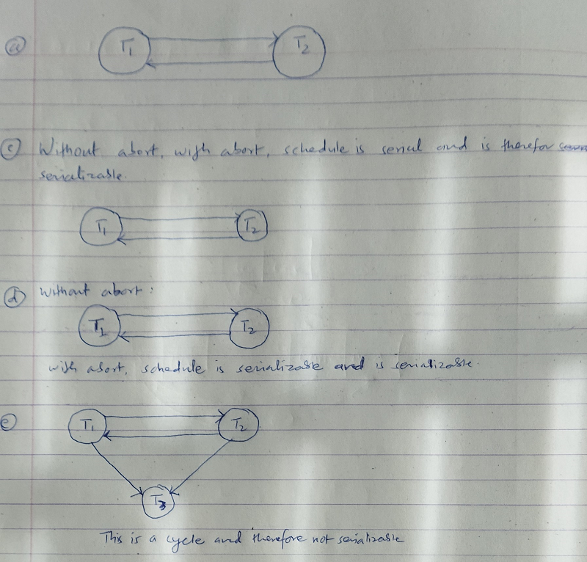
7. 22.22/20.22 (5th/4th edition)

